GRACE

SPECIFICATION

ROHS Compliant Parts

Customer ：
Part Name ： Chip NTC Thermistor
Part Number ： KNTC-N Series

Address：Songhu Information Industrial Park.GuanminTou,Chashan Town,
Dongguan ,Guangdong ,China
Tel：0769-22008861 Web：www.gracevn.com Email：grace@gracevn.com

Dongguan GRACE electronic Technology Co., LTD

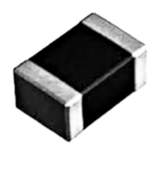
Chip NTC Thermistor — KNTC - N series

For Temperature Sensing - Blocky structure

■ Features

■ Accurate temperature measurement from -40 °C to 125°C
■ Excellent long-term aging stability in high temperature and high humidity environment
■ Tight R- and B- tolerances
■ Short response time
■ 100% Pb free, RoHS
■ Applications

■ Temperature compensation for transistors, ICs, and crystal oscillators in mobile communications
■ Temperature sensor for rechargeable batteries
■ Temperature compensation of LCD
■ Temperature measurement and compensation in general use of electric circuits
■ Explanation of Part Numbers

KNTC | 0402 | N | 332 | F | 3500 | F | A | A | K000 | T
① | ② | ③ | ④ | ⑤ | ⑥ | ⑦ | ⑧ | ⑨ | ⑩ | ⑪

① | Series
GRACE
Chip NTC Thermistor
② | Chip size  (EIA)
0402
0603
0805
1206
④ | Nominal resistance  R₂₅(Ω)
300 | 30
101 | 100
102 | 1000
103 | 10000
③ | Series code
N | Blocky

⑤ | Resistance tolerance
F | ±1%
G | ±2%
H | ±3%
J | ±5%
K | ±10%
⑥ | B Constant
3500 | 3500K
⑦ | B Constant  tolerance
F | ±1%
H | ±3%
⑧ | Definition of  B Value
A | 25/50
B | 25/85
C | 25/100

⑨ | internal code
A
⑩ | Customer identification code
K000
⑪ | Packaging  style
T | Tape
B | Bulk

■ Construction

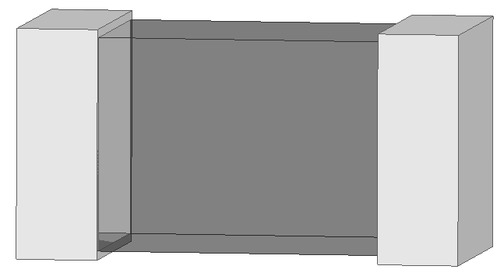

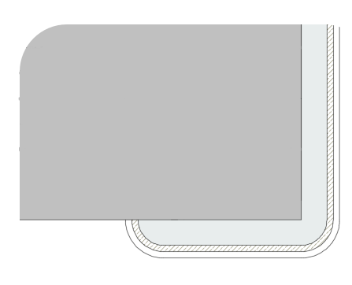

Blocky structure

No. | Name
① | Semiconductive Ceramics
② | Terminal electrode | Ag
③ | Terminal electrode | Ni
④ | Terminal electrode | Sn
② ③ ④

■ Shape and Dimensions

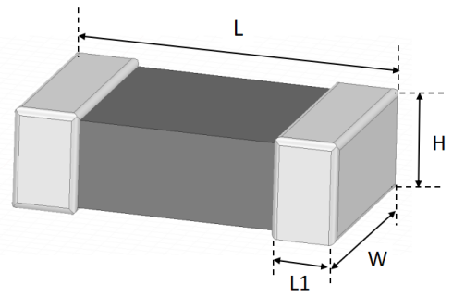
1）Dimensions： 2）Recommended PCB pattern for reflow soldering:
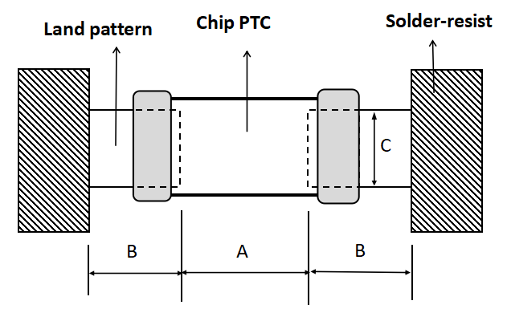

Unit: mm
Size （EIA/JIS) | L | W | H | L1 | A | B | C
0402/1005 | 1.00±0.05 | 0.50±0.05 | 0.50±0.05 | 0.3±0.10 | 0.45~0.55 | 0.40~0.50 | 0.45~0.55
0603/1608 | 1.60±0.20 | 0.80±0.20 | 0.80±0.20 | 0.30±0.20 | 0.60~0.80 | 0.60~0.80 | 0.60~0.80
0805/2012 | 2.00±0.20 | 1.20±0.20 | 0.80±0.20 | 0.40±0.20 | 0.80~1.20 | 0.80~1.20 | 0.90~1.60
1206/3216 | 3.20±0.20 | 1.60±0.20 | 1.20±0.20 | 0.40±0.30 | 1.80~2.50 | 1.00~1.50 | 1.20~2.00

■Parameter definition and specification

Size(inch) | 0402 | 0603 | 0805 | 1206
Max. Rated power at 25℃(mW）*1 | 100 | 100 | 200 | 300
Dissipation factors at 25℃（mW /℃）*2 | 1 | 1 | 2 | 3
Thermal Time Constant（Sec.） | Approx 3 | Approx 4.5 | Approx 5 | Approx 9
^{1*} Max.Rated power: at rated temperature (25℃), maximum power that can be applied continuously.
^{2*} Dissipation factors: powered that it is equivalent that be increased in self-heating by load power thermistor at 1℃ temperature.

■ Electrical Characteristics

0402 Type
Part Number | Zero Power  Resistance at 25℃ | Tolerance  of R25 | B constant | Tolerance  of B constant | Max.Permissible Operating Current  at 25℃
Part Number | （KΩ） | （±%） | （K） | （±%） | （mA）
KNTC0402N332□3500□A□□T | 3.3 | 1 , 2 , 3 , 5 , 10 | 3500 | 1 , 3 | 0.55
KNTC0402N682□3500□A□□T | 6.8 | 1 , 2 , 3 , 5 , 10 | 3500 | 1 , 3 | 0.38
KNTC0402N103□3380□A□□T | 10 | 1 , 2 , 3 , 5 , 10 | 3380 | 1 , 3 | 0.32
KNTC0402N103□3435□B□□T | 10 | 1 , 2 , 3 , 5 , 10 | 3450 | 1 , 3 | 0.32
KNTC0402N103□3950□A□□T | 10 | 1 , 2 , 3 , 5 , 10 | 3950 | 1 , 3 | 0.32
KNTC0402N103□4050□A□□T | 10 | 1 , 2 , 3 , 5 , 10 | 4050 | 1 , 3 | 0.32
KNTC0402N223□3950□A□□T | 22 | 1 , 2 , 3 , 5 , 10 | 3950 | 1 , 3 | 0.21
KNTC0402N333□3950□A□□T | 33 | 1 , 2 , 3 , 5 , 10 | 3950 | 1 , 3 | 0.17
KNTC0402N473□4100□A□□T | 47 | 1 , 2 , 3 , 5 , 10 | 4100 | 1 , 3 | 0.15
KNTC0402N503□3950□A□□T | 50 | 1 , 2 , 3 , 5 , 10 | 3950 | 1 , 3 | 0.14
KNTC0402N683□4150□A□□T | 68 | 1 , 2 , 3 , 5 , 10 | 4150 | 1 , 3 | 0.12
KNTC0402N104□3950□A□□T | 100 | 1 , 2 , 3 , 5 , 10 | 3950 | 1 , 3 | 0.10
KNTC0402N104□4150□A□□T | 100 | 1 , 2 , 3 , 5 , 10 | 4150 | 1 , 3 | 0.10
KNTC0402N104□4250□A□□T | 100 | 1 , 2 , 3 , 5 , 10 | 4250 | 1 , 3 | 0.10
KNTC0402N154□4150□A□□T | 150 | 1 , 2 , 3 , 5 , 10 | 4150 | 1 , 3 | 0.08
KNTC0402N224□3950□A□□T | 220 | 1 , 2 , 3 , 5 , 10 | 3950 | 1 , 3 | 0.07
KNTC0402N334□4050□A□□T | 330 | 1 , 2 , 3 , 5 , 10 | 4050 | 1 , 3 | 0.06
KNTC0402N474□4050□A□□T | 470 | 1 , 2 , 3 , 5 , 10 | 4050 | 1 , 3 | 0.05

0603 Type
Part Number | Zero Power  Resistance at 25℃ | Tolerance  of R25 | B constant | Tolerance  of B constant | Max.Permissible Operating Current  at 25℃
Part Number | （KΩ） | （±%） | （K） | （±%） | （mA）
KNTC0603N221□2750□B□□T | 0.22 | 1 , 2 , 3 , 5 , 10 | 2750 | 1 , 3 | 2.13
KNTC0603N331□3000□B□□T | 0.33 | 1 , 2 , 3 , 5 , 10 | 3000 | 1 , 3 | 1.74
KNTC0603N471□3000□B□□T | 0.47 | 1 , 2 , 3 , 5 , 10 | 3000 | 1 , 3 | 1.46
KNTC0603N681□3000□B□□T | 0.68 | 1 , 2 , 3 , 5 , 10 | 3000 | 1 , 3 | 1.21
KNTC0603N102□2950□B□□T | 1 | 1 , 2 , 3 , 5 , 10 | 2950 | 1 , 3 | 1
KNTC0603N102□3200□A□□T | 1 | 1 , 2 , 3 , 5 , 10 | 3200 | 1 , 3 | 1
KNTC0603N102□3500□A□□T | 1 | 1 , 2 , 3 , 5 , 10 | 3500 | 1 , 3 | 1
KNTC0603N152□3200□A□□T | 1.5 | 1 , 2 , 3 , 5 , 10 | 3200 | 1 , 3 | 0.82
KNTC0603N202□3400□A□□T | 2 | 1 , 2 , 3 , 5 , 10 | 3400 | 1 , 3 | 0.71
KNTC0603N202□4050□A□□T | 2 | 1 , 2 , 3 , 5 , 10 | 4050 | 1 , 3 | 0.71
KNTC0603N222□3450□A□□T | 2.2 | 1 , 2 , 3 , 5 , 10 | 3450 | 1 , 3 | 0.67
KNTC0603N222□3500□A□□T | 2.2 | 1 , 2 , 3 , 5 , 10 | 3500 | 1 , 3 | 0.67
KNTC0603N222□3950□A□□T | 2.2 | 1 , 2 , 3 , 5 , 10 | 3950 | 1 , 3 | 0.67
KNTC0603N302□3500□A□□T | 3 | 1 , 2 , 3 , 5 , 10 | 3500 | 1 , 3 | 0.58
KNTC0603N332□3200□A□□T | 3.3 | 1 , 2 , 3 , 5 , 10 | 3200 | 1 , 3 | 0.55
KNTC0603N332□3300□A□□T | 3.3 | 1 , 2 , 3 , 5 , 10 | 3300 | 1 , 3 | 0.55
KNTC0603N332□3500□A□□T | 3.3 | 1 , 2 , 3 , 5 , 10 | 3500 | 1 , 3 | 0.55
KNTC0603N332□3950□A□□T | 3.3 | 1 , 2 , 3 , 5 , 10 | 3950 | 1 , 3 | 0.55
KNTC0603N472□3340□B□□T | 4.7 | 1 , 2 , 3 , 5 , 10 | 3340 | 1 , 3 | 0.46
KNTC0603N472□3500□A□□T | 4.7 | 1 , 2 , 3 , 5 , 10 | 3500 | 1 , 3 | 0.46
KNTC0603N472□3950□A□□T | 4.7 | 1 , 2 , 3 , 5 , 10 | 3950 | 1 , 3 | 0.46
KNTC0603N502□3340□B□□T | 5 | 1 , 2 , 3 , 5 , 10 | 3340 | 1 , 3 | 0.45
KNTC0603N502□3435□B□□T | 5 | 1 , 2 , 3 , 5 , 10 | 3435 | 1 , 3 | 0.45
KNTC0603N502□3950□A□□T | 5 | 1 , 2 , 3 , 5 , 10 | 3950 | 1 , 3 | 0.45
KNTC0603N682□3950□A□□T | 6.8 | 1 , 2 , 3 , 5 , 10 | 3950 | 1 , 3 | 0.38
KNTC0603N822□3600□A□□T | 8.2 | 1 , 2 , 3 , 5 , 10 | 3600 | 1 , 3 | 0.35
KNTC0603N103□3380□A□□T | 10 | 1 , 2 , 3 , 5 , 10 | 3380 | 1 , 3 | 0.32
KNTC0603N103□3435□B□□T | 10 | 1 , 2 , 3 , 5 , 10 | 3435 | 1 , 3 | 0.32
KNTC0603N103□3450□A□□T | 10 | 1 , 2 , 3 , 5 , 10 | 3450 | 1 , 3 | 0.32
KNTC0603N103□3500□A□□T | 10 | 1 , 2 , 3 , 5 , 10 | 3500 | 1 , 3 | 0.32
KNTC0603N103□3600□A□□T | 10 | 1 , 2 , 3 , 5 , 10 | 3600 | 1 , 3 | 0.32
KNTC0603N103□3900□A□□T | 10 | 1 , 2 , 3 , 5 , 10 | 3900 | 1 , 3 | 0.32
KNTC0603N103□3950□A□□T | 10 | 1 , 2 , 3 , 5 , 10 | 3950 | 1 , 3 | 0.32
KNTC0603N123□3500□A□□T | 12 | 1 , 2 , 3 , 5 , 10 | 3500 | 1 , 3 | 0.29
KNTC0603N153□3500□A□□T | 15 | 1 , 2 , 3 , 5 , 10 | 3500 | 1 , 3 | 0.26
KNTC0603N153□3950□A□□T | 15 | 1 , 2 , 3 , 5 , 10 | 3950 | 1 , 3 | 0.26
KNTC0603N203□3300□A□□T | 20 | 1 , 2 , 3 , 5 , 10 | 3300 | 1 , 3 | 0.22
KNTC0603N223□3300□A□□T | 22 | 1 , 2 , 3 , 5 , 10 | 3300 | 1 , 3 | 0.21
KNTC0603N223□3500□A□□T | 22 | 1 , 2 , 3 , 5 , 10 | 3500 | 1 , 3 | 0.21
KNTC0603N223□3950□A□□T | 22 | 1 , 2 , 3 , 5 , 10 | 3950 | 1 , 3 | 0.21
KNTC0603N223□4050□A□□T | 22 | 1 , 2 , 3 , 5 , 10 | 4050 | 1 , 3 | 0.21
KNTC0603N223□4150□A□□T | 22 | 1 , 2 , 3 , 5 , 10 | 4150 | 1 , 3 | 0.21
KNTC0603N303□3950□A□□T | 30 | 1 , 2 , 3 , 5 , 10 | 3950 | 1 , 3 | 0.18
KNTC0603N333□3950□A□□T | 33 | 1 , 2 , 3 , 5 , 10 | 3950 | 1 , 3 | 0.17
KNTC0603N333□4050□A□□T | 33 | 1 , 2 , 3 , 5 , 10 | 4050 | 1 , 3 | 0.17
KNTC0603N333□4150□A□□T | 33 | 1 , 2 , 3 , 5 , 10 | 4150 | 1 , 3 | 0.17
KNTC0603N473□3950□A□□T | 47 | 1 , 2 , 3 , 5 , 10 | 3950 | 1 , 3 | 0.15
KNTC0603N473□4050□A□□T | 47 | 1 , 2 , 3 , 5 , 10 | 4050 | 1 , 3 | 0.15
KNTC0603N473□4150□A□□T | 47 | 1 , 2 , 3 , 5 , 10 | 4150 | 1 , 3 | 0.15
KNTC0603N503□3950□A□□T | 50 | 1 , 2 , 3 , 5 , 10 | 3950 | 1 , 3 | 0.14
KNTC0603N683□4050□A□□T | 68 | 1 , 2 , 3 , 5 , 10 | 4050 | 1 , 3 | 0.12
KNTC0603N683□4150□A□□T | 68 | 1 , 2 , 3 , 5 , 10 | 4150 | 1 , 3 | 0.12
KNTC0603N753□3900□A□□T | 75 | 1 , 2 , 3 , 5 , 10 | 3900 | 1 , 3 | 0.12
KNTC0603N104□3950□A□□T | 100 | 1 , 2 , 3 , 5 , 10 | 3950 | 1 , 3 | 0.1
KNTC0603N104□4150□A□□T | 100 | 1 , 2 , 3 , 5 , 10 | 4150 | 1 , 3 | 0.1
KNTC0603N104□4250□A□□T | 100 | 1 , 2 , 3 , 5 , 10 | 4250 | 1 , 3 | 0.1
KNTC0603N124□3950□A□□T | 120 | 1 , 2 , 3 , 5 , 10 | 3950 | 1 , 3 | 0.09
KNTC0603N154□3950□A□□T | 150 | 1 , 2 , 3 , 5 , 10 | 3950 | 1 , 3 | 0.08
KNTC0603N154□4200□A□□T | 150 | 1 , 2 , 3 , 5 , 10 | 4200 | 1 , 3 | 0.08
KNTC0603N154□4300□A□□T | 150 | 1 , 2 , 3 , 5 , 10 | 4300 | 1 , 3 | 0.08
KNTC0603N204□3950□A□□T | 200 | 1 , 2 , 3 , 5 , 10 | 3950 | 1 , 3 | 0.07
KNTC0603N224□3950□A□□T | 220 | 1 , 2 , 3 , 5 , 10 | 3950 | 1 , 3 | 0.07
KNTC0603N224□4200□A□□T | 220 | 1 , 2 , 3 , 5 , 10 | 4200 | 1 , 3 | 0.07
KNTC0603N224□4350□A□□T | 220 | 1 , 2 , 3 , 5 , 10 | 4350 | 1 , 3 | 0.07
KNTC0603N334□4200□A□□T | 330 | 1 , 2 , 3 , 5 , 10 | 4200 | 1 , 3 | 0.06
KNTC0603N474□4000□A□□T | 470 | 1 , 2 , 3 , 5 , 10 | 4000 | 1 , 3 | 0.05
KNTC0603N474□4200□A□□T | 470 | 1 , 2 , 3 , 5 , 10 | 4200 | 1 , 3 | 0.05
KNTC0603N564□4300□A□□T | 560 | 1 , 2 , 3 , 5 , 10 | 4300 | 1 , 3 | 0.04
KNTC0603N684□4100□B□□T | 680 | 1 , 2 , 3 , 5 , 10 | 4100 | 1 , 3 | 0.04
KNTC0603N684□4150□A□□T | 680 | 1 , 2 , 3 , 5 , 10 | 4150 | 1 , 3 | 0.04
KNTC0603N105□4200□B□□T | 1000 | 1 , 2 , 3 , 5 , 10 | 4200 | 1 , 3 | 0.03
KNTC0603N105□4300□A□□T | 1000 | 1 , 2 , 3 , 5 , 10 | 4300 | 1 , 3 | 0.03
KNTC0603N205□4300□B□□T | 2000 | 1 , 2 , 3 , 5 , 10 | 4300 | 1 , 3 | 0.02

0805 Type
Part Number | Zero Power  Resistance at 25℃ | Tolerance  of R25 | B constant | Tolerance  of B constant | Max.Permissible Operating Current  at 25℃
Part Number | （KΩ） | （±%） | （K） | （±%） | （mA）
KNTC0805N150□2800□B□□T | 0.015 | 1 , 2 , 3 , 5 , 10 | 2800 | 1 , 3 | 11.54
KNTC0805N220□2800□B□□T | 0.022 | 1 , 2 , 3 , 5 , 10 | 2800 | 1 , 3 | 9.53
KNTC0805N330□2800□B□□T | 0.033 | 1 , 2 , 3 , 5 , 10 | 2800 | 1 , 3 | 7.78
KNTC0805N470□2800□B□□T | 0.047 | 1 , 2 , 3 , 5 , 10 | 2800 | 1 , 3 | 6.52
KNTC0805N500□2800□B□□T | 0.050 | 1 , 2 , 3 , 5 , 10 | 2800 | 1 , 3 | 6.32
KNTC0805N680□2800□B□□T | 0.068 | 1 , 2 , 3 , 5 , 10 | 2800 | 1 , 3 | 5.42
KNTC0805N800□2800□B□□T | 0.080 | 1 , 2 , 3 , 5 , 10 | 2800 | 1 , 3 | 5.00
KNTC0805N101□3000□B□□T | 0.100 | 1 , 2 , 3 , 5 , 10 | 3000 | 1 , 3 | 4.47
KNTC0805N121□3000□B□□T | 0.120 | 1 , 2 , 3 , 5 , 10 | 3000 | 1 , 3 | 4.08
KNTC0805N151□3000□B□□T | 0.150 | 1 , 2 , 3 , 5 , 10 | 3000 | 1 , 3 | 3.65
KNTC0805N181□3000□B□□T | 0.180 | 1 , 2 , 3 , 5 , 10 | 3000 | 1 , 3 | 3.33
KNTC0805N221□3000□B□□T | 0.220 | 1 , 2 , 3 , 5 , 10 | 3000 | 1 , 3 | 3.02
KNTC0805N331□3000□B□□T | 0.330 | 1 , 2 , 3 , 5 , 10 | 3000 | 1 , 3 | 2.46
KNTC0805N431□3000□B□□T | 0.430 | 1 , 2 , 3 , 5 , 10 | 3000 | 1 , 3 | 2.16
KNTC0805N471□3000□B□□T | 0.470 | 1 , 2 , 3 , 5 , 10 | 3000 | 1 , 3 | 2.06
KNTC0805N681□3000□B□□T | 0.680 | 1 , 2 , 3 , 5 , 10 | 3000 | 1 , 3 | 1.71
KNTC0805N102□3200□A□□T | 1 | 1 , 2 , 3 , 5 , 10 | 3200 | 1 , 3 | 1.41
KNTC0805N102□3500□A□□T | 1 | 1 , 2 , 3 , 5 , 10 | 3500 | 1 , 3 | 1.41
KNTC0805N102□3950□A□□T | 1 | 1 , 2 , 3 , 5 , 10 | 3950 | 1 , 3 | 1.41
KNTC0805N152□3400□A□□T | 1.5 | 1 , 2 , 3 , 5 , 10 | 3400 | 1 , 3 | 1.15
KNTC0805N202□3200□B□□T | 2.0 | 1 , 2 , 3 , 5 , 10 | 3200 | 1 , 3 | 1.00
KNTC0805N202□3400□A□□T | 2.0 | 1 , 2 , 3 , 5 , 10 | 3400 | 1 , 3 | 1.00
KNTC0805N222□3200□B□□T | 2.2 | 1 , 2 , 3 , 5 , 10 | 3200 | 1 , 3 | 0.95
KNTC0805N222□3500□A□□T | 2.2 | 1 , 2 , 3 , 5 , 10 | 3500 | 1 , 3 | 0.95
KNTC0805N222□3950□A□□T | 2.2 | 1 , 2 , 3 , 5 , 10 | 3500 | 1 , 3 | 0.95
KNTC0805N302□3450□A□□T | 3 | 1 , 2 , 3 , 5 , 10 | 3450 | 1 , 3 | 0.82
KNTC0805N332□3300□A□□T | 3.3 | 1 , 2 , 3 , 5 , 10 | 3300 | 1 , 3 | 0.78
KNTC0805N332□3500□A□□T | 3.3 | 1 , 2 , 3 , 5 , 10 | 3500 | 1 , 3 | 0.78
KNTC0805N332□3950□A□□T | 3.3 | 1 , 2 , 3 , 5 , 10 | 3950 | 1 , 3 | 0.78
KNTC0805N472□3500□A□□T | 4.7 | 1 , 2 , 3 , 5 , 10 | 3500 | 1 , 3 | 0.65
KNTC0805N472□3950□A□□T | 4.7 | 1 , 2 , 3 , 5 , 10 | 3950 | 1 , 3 | 0.65
KNTC0805N502□3435□B□□T | 5 | 1 , 2 , 3 , 5 , 10 | 3435 | 1 , 3 | 0.63
KNTC0805N502□3950□A□□T | 5 | 1 , 2 , 3 , 5 , 10 | 3950 | 1 , 3 | 0.63
KNTC0805N682□3500□A□□T | 6.8 | 1 , 2 , 3 , 5 , 10 | 3500 | 1 , 3 | 0.54
KNTC0805N682□3650□A□□T | 6.8 | 1 , 2 , 3 , 5 , 10 | 3650 | 1 , 3 | 0.54
KNTC0805N682□3950□A□□T | 6.8 | 1 , 2 , 3 , 5 , 10 | 3950 | 1 , 3 | 0.54
KNTC0805N822□3500□A□□T | 8.2 | 1 , 2 , 3 , 5 , 10 | 3500 | 1 , 3 | 0.49
KNTC0805N822□3950□A□□T | 8.2 | 1 , 2 , 3 , 5 , 10 | 3950 | 1 , 3 | 0.49
KNTC0805N103□3380□A□□T | 10 | 1 , 2 , 3 , 5 , 10 | 3380 | 1 , 3 | 0.45
KNTC0805N103□3435□B□□T | 10 | 1 , 2 , 3 , 5 , 10 | 3435 | 1 , 3 | 0.45
KNTC0805N103□3450□A□□T | 10 | 1 , 2 , 3 , 5 , 10 | 3450 | 1 , 3 | 0.45
KNTC0805N103□3500□A□□T | 10 | 1 , 2 , 3 , 5 , 10 | 3500 | 1 , 3 | 0.45
KNTC0805N103□3950□A□□T | 10 | 1 , 2 , 3 , 5 , 10 | 3950 | 1 , 3 | 0.45
KNTC0805N153□3500□A□□T | 15 | 1 , 2 , 3 , 5 , 10 | 3500 | 1 , 3 | 0.37
KNTC0805N153□3900□A□□T | 15 | 1 , 2 , 3 , 5 , 10 | 3900 | 1 , 3 | 0.37
KNTC0805N153□4100□A□□T | 15 | 1 , 2 , 3 , 5 , 10 | 4100 | 1 , 3 | 0.37
KNTC0805N203□3950□A□□T | 20 | 1 , 2 , 3 , 5 , 10 | 3950 | 1 , 3 | 0.32
KNTC0805N223□3950□A□□T | 22 | 1 , 2 , 3 , 5 , 10 | 3950 | 1 , 3 | 0.30
KNTC0805N223□4050□A□□T | 22 | 1 , 2 , 3 , 5 , 10 | 4050 | 1 , 3 | 0.30
KNTC0805N223□4150□A□□T | 22 | 1 , 2 , 3 , 5 , 10 | 4150 | 1 , 3 | 0.30
KNTC0805N303□3950□A□□T | 30 | 1 , 2 , 3 , 5 , 10 | 3950 | 1 , 3 | 0.26
KNTC0805N303□4050□A□□T | 30 | 1 , 2 , 3 , 5 , 10 | 4050 | 1 , 3 | 0.26
KNTC0805N333□3950□A□□T | 33 | 1 , 2 , 3 , 5 , 10 | 3950 | 1 , 3 | 0.25
KNTC0805N333□4050□A□□T | 33 | 1 , 2 , 3 , 5 , 10 | 4050 | 1 , 3 | 0.25
KNTC0805N333□4150□A□□T | 33 | 1 , 2 , 3 , 5 , 10 | 4150 | 1 , 3 | 0.25
KNTC0805N473□3950□A□□T | 47 | 1 , 2 , 3 , 5 , 10 | 3950 | 1 , 3 | 0.21
KNTC0805N473□4050□A□□T | 47 | 1 , 2 , 3 , 5 , 10 | 4050 | 1 , 3 | 0.21
KNTC0805N473□4150□A□□T | 47 | 1 , 2 , 3 , 5 , 10 | 4150 | 1 , 3 | 0.21
KNTC0805N503□3950□A□□T | 50 | 1 , 2 , 3 , 5 , 10 | 3950 | 1 , 3 | 0.20
KNTC0805N503□4150□A□□T | 50 | 1 , 2 , 3 , 5 , 10 | 4150 | 1 , 3 | 0.20
KNTC0805N683□4050□A□□T | 68 | 1 , 2 , 3 , 5 , 10 | 4050 | 1 , 3 | 0.17
KNTC0805N683□4150□A□□T | 68 | 1 , 2 , 3 , 5 , 10 | 4150 | 1 , 3 | 0.17
KNTC0805N753□3900□A□□T | 75 | 1 , 2 , 3 , 5 , 10 | 3900 | 1 , 3 | 0.16
KNTC0805N823□3950□A□□T | 82 | 1 , 2 , 3 , 5 , 10 | 3950 | 1 , 3 | 0.16
KNTC0805N104□3950□A□□T | 100 | 1 , 2 , 3 , 5 , 10 | 3950 | 1 , 3 | 0.14
KNTC0805N104□4250□A□□T | 100 | 1 , 2 , 3 , 5 , 10 | 4250 | 1 , 3 | 0.14
KNTC0805N154□4050□A□□T | 150 | 1 , 2 , 3 , 5 , 10 | 4050 | 1 , 3 | 0.12
KNTC0805N154□4300□A□□T | 150 | 1 , 2 , 3 , 5 , 10 | 4300 | 1 , 3 | 0.12
KNTC0805N204□4050□A□□T | 200 | 1 , 2 , 3 , 5 , 10 | 4050 | 1 , 3 | 0.10
KNTC0805N224□3900□A□□T | 220 | 1 , 2 , 3 , 5 , 10 | 3900 | 1 , 3 | 0.10
KNTC0805N224□4050□A□□T | 220 | 1 , 2 , 3 , 5 , 10 | 4050 | 1 , 3 | 0.10
KNTC0805N224□4350□A□□T | 220 | 1 , 2 , 3 , 5 , 10 | 4350 | 1 , 3 | 0.10
KNTC0805N334□4200□A□□T | 330 | 1 , 2 , 3 , 5 , 10 | 4200 | 1 , 3 | 0.08
KNTC0805N474□4200□A□□T | 470 | 1 , 2 , 3 , 5 , 10 | 4200 | 1 , 3 | 0.07
KNTC0805N504□4100□B□□T | 500 | 1 , 2 , 3 , 5 , 10 | 4100 | 1 , 3 | 0.06
KNTC0805N564□4300□A□□T | 560 | 1 , 2 , 3 , 5 , 10 | 4300 | 1 , 3 | 0.06
KNTC0805N664□4150□A□□T | 660 | 1 , 2 , 3 , 5 , 10 | 4150 | 1 , 3 | 0.06
KNTC0805N684□4100□B□□T | 680 | 1 , 2 , 3 , 5 , 10 | 4100 | 1 , 3 | 0.05
KNTC0805N684□4200□A□□T | 680 | 1 , 2 , 3 , 5 , 10 | 4200 | 1 , 3 | 0.05
KNTC0805N105□4250□B□□T | 1000 | 1 , 2 , 3 , 5 , 10 | 4250 | 1 , 3 | 0.04
KNTC0805N105□4500□A□□T | 1000 | 1 , 2 , 3 , 5 , 10 | 4500 | 1 , 3 | 0.04

1206 Type
Part Number | Zero Power  Resistance at 25℃ | Tolerance  of R25 | B constant | Tolerance  of B constant | Max.Permissible Operating Current  at 25℃
Part Number | （KΩ） | （±%） | （K） | （±%） | （mA）
KNTC1206N102□3200□A□□T | 1 | 1 , 2 , 3 , 5 , 10 | 3200 | 1 , 3 | 1.73
KNTC1206N222□3450□A□□T | 2.2 | 1 , 2 , 3 , 5 , 10 | 3450 | 1 , 3 | 1.16
KNTC1206N332□3450□A□□T | 3.3 | 1 , 2 , 3 , 5 , 10 | 3450 | 1 , 3 | 0.95
KNTC1206N472□3500□A□□T | 4.7 | 1 , 2 , 3 , 5 , 10 | 3500 | 1 , 3 | 0.80
KNTC1206N472□3950□A□□T | 4.7 | 1 , 2 , 3 , 5 , 10 | 3950 | 1 , 3 | 0.80
KNTC1206N502□3800□A□□T | 5 | 1 , 2 , 3 , 5 , 10 | 3800 | 1 , 3 | 0.77
KNTC1206N502□3950□A□□T | 5 | 1 , 2 , 3 , 5 , 10 | 3950 | 1 , 3 | 0.77
KNTC1206N103□3500□A□□T | 10 | 1 , 2 , 3 , 5 , 10 | 3500 | 1 , 3 | 0.55
KNTC1206N103□3950□A□□T | 10 | 1 , 2 , 3 , 5 , 10 | 3950 | 1 , 3 | 0.55
KNTC1206N223□3950□A□□T | 22 | 1 , 2 , 3 , 5 , 10 | 3950 | 1 , 3 | 0.37
KNTC1206N223□4150□A□□T | 22 | 1 , 2 , 3 , 5 , 10 | 4150 | 1 , 3 | 0.37
KNTC1206N333□3950□A□□T | 33 | 1 , 2 , 3 , 5 , 10 | 3950 | 1 , 3 | 0.30
KNTC1206N473□3950□A□□T | 47 | 1 , 2 , 3 , 5 , 10 | 3950 | 1 , 3 | 0.25
KNTC1206N473□4050□A□□T | 47 | 1 , 2 , 3 , 5 , 10 | 4050 | 1 , 3 | 0.25
KNTC1206N473□4150□A□□T | 47 | 1 , 2 , 3 , 5 , 10 | 4150 | 1 , 3 | 0.25
KNTC1206N503□3800□A□□T | 50 | 1 , 2 , 3 , 5 , 10 | 3800 | 1 , 3 | 0.24
KNTC1206N503□3950□A□□T | 50 | 1 , 2 , 3 , 5 , 10 | 3950 | 1 , 3 | 0.24
KNTC1206N683□3800□A□□T | 68 | 1 , 2 , 3 , 5 , 10 | 3800 | 1 , 3 | 0.21
KNTC1206N683□4150□A□□T | 68 | 1 , 2 , 3 , 5 , 10 | 4150 | 1 , 3 | 0.21
KNTC1206N104□3950□A□□T | 100 | 1 , 2 , 3 , 5 , 10 | 3950 | 1 , 3 | 0.17
KNTC1206N104□4150□A□□T | 100 | 1 , 2 , 3 , 5 , 10 | 4150 | 1 , 3 | 0.17
KNTC1206N224□4050□A□□T | 220 | 1 , 2 , 3 , 5 , 10 | 4050 | 1 , 3 | 0.12
KNTC1206N334□4050□A□□T | 330 | 1 , 2 , 3 , 5 , 10 | 4050 | 1 , 3 | 0.10
KNTC1206N474□4200□A□□T | 470 | 1 , 2 , 3 , 5 , 10 | 4200 | 1 , 3 | 0.08

※ The above data were tested in stationary air at 25℃ with unmounted independent units.
■ Description and definition of terms

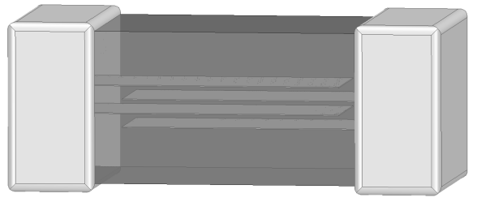
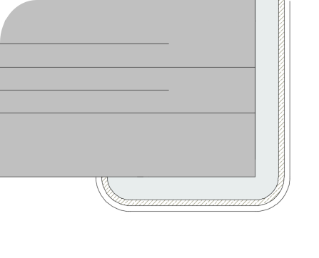

No. | Name
① | Semiconductive Ceramics
② | Internal electrode
③ | Terminal electrode | Ag
④ | Terminal electrode | Ni
⑤ | Terminal electrode | Sn

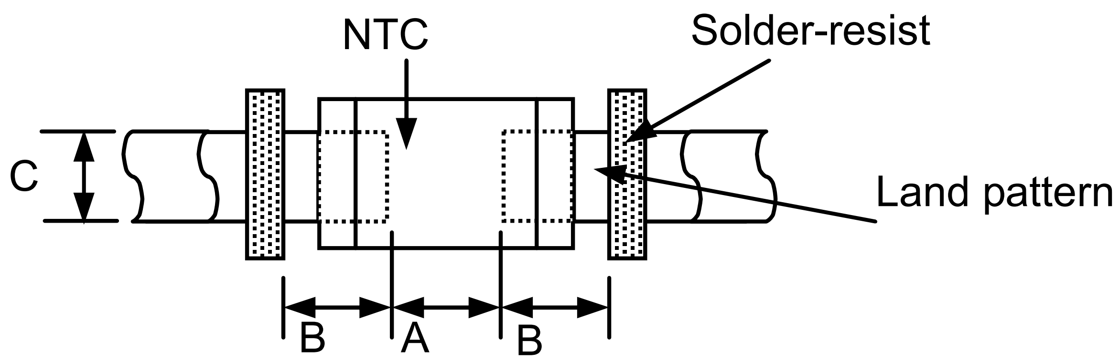

No. | Items | Test Methods and Remarks
1 | Nominal Zero-Power Resistance (R25) | Ambient temperature: 25±0.2C .  Measuring electric power: 0. 32mW Max.  ※ Thermistor resistance is a function of absolute temperature as indicated by the following relationship:  R=R0 expB (1/T-1/T0)  Here R0, R(kΩ) are the respective resistance values when the surrounding temperature is T0, T(K).  B is the thermistor constant(B constant below)
2 | Nominal B  Constant | The resistances R₁ and R₂ measured at ambient temperatures T₁ and T₂ respectively  $${ B}_{T1/T2}=\frac{In(R_{1})−In(R_{2})}{1/(T_{1}+273.15)−1/(T_{2}+273.15)}$$
   | T1 | T2
  B25/50 | 25℃±0.1℃ | 50℃±0.1℃
  B25/85 | 25℃±0.1℃ | 85℃±0.1℃
 | Thermal Time  Constant | The total time for the temperature of the thermistor to change by 63.2% of the difference from ambient temperature T₀ (℃) to T₁ (℃) by the drastic change of the power applied to thermistor from Non-zero Power to Zero-Power state.  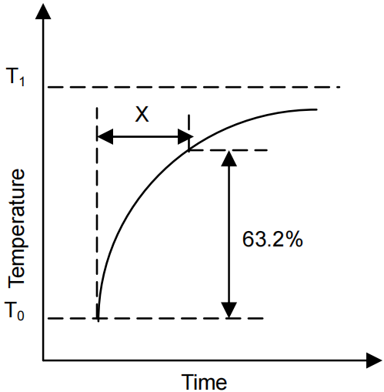
3 | Thermal Time  Constant
Items | Requirements | Test Methods and Remarks
4 | Dissipation Constant | The total electric power required to raise the temperature of the element by 1℃ through self-heating under thermal equilibrium. It calculates by next formula.  $$C=\frac{W}{{T−T}_{0}}$$  When a thermistor is used for temperature measurement, it is naturally important to lower the applied electrical current as much as possible in order to reduce measurement error resulting from self heating.
5 | Rated Power | The necessary electric power makes thermistor’s temperature rise 100℃ by self-heating at ambient temperature 25C .
6 | Permissive  operating current | The current that keeps body temperature of chip NTC on the PC board in still air rising 1°C by self-heating.

■ Reliability Test

No. | Name
① | Semiconductive Ceramics
② | Internal electrode
③ | Terminal electrode | Ag
④ | Terminal electrode | Ni
⑤ | Terminal electrode | Sn

Items |  | Requirements | Test Methods and Remarks
Terminal  Strength |  | No removal or split of the termination or other defects shall occur. | Solder the chip to the testing jig (glass epoxy board shown in the following Fig. 1-1) using eutectic solder. Then apply a force in the direction of the arrow.
  Size（EIA） | Force | Duration
  0402、0603 | 5N | 10±1s
  0805、1206 | 10N | 10±1s
Fig.1-1
F
Chip
Mounting Pad
Glass Epoxy Board
Resistance to  Flexure |  | No visible mechanical damage. | Solder the chip to the test jig (glass epoxy board shown in Fig.2-1) using a eutectic solder. Then apply a force in thedirection shown in Fig. 2-2.  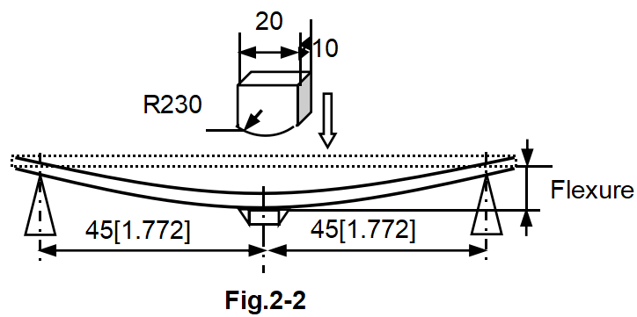
  Size（EIA） | Flexure | Pressurizing  Speed | Duration
  0402、0603、0805、1206 | 2mm | ＜0.5mm/s | 10±1s
 |  | Unit: mm
Size（EIA） | a | b | c
0402 | 0.4 | 1.5 | 0.5
0603 | 1.0 | 3.0 | 1.2
0805 | 1.2 | 4.0 | 1.65
1206 | 2.2 | 5.0 | 2.0

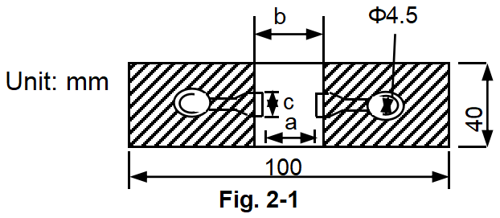
Items |  | Requirements | Test Methods and Remarks
Vibration |  | No visible mechanical damage. | - Solder the chip to the testing jig (glass epoxy board shown in Fig.3-1) using eutectic solder.  - The chip shall be subjected to a simple harmonic motion having total amplitude of 1.5mm, the frequency being varied uniformly between the approximate limits of 10 and 55 Hz.  - The frequency ranging from 10 to 55 Hz and returning to 10 Hz shall be traversed in approximately 1 minute. This motion shall be applied for a period of 2 hours in each 3 mutually perpendicular directions (total of 6 hours).
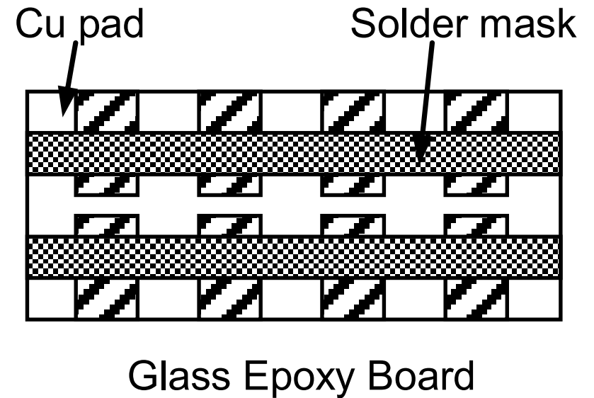

Fig. 3-1
Dropping |  | No visible mechanical damage. | Drop chip inductor 10 times on a concrete floor from a height of 100 cm.
Solderability |  | - No visible mechanical damage.  - Wetting shall exceed 80% coverage. | - Solder temperature: 240±2C .  - Duration: 3 sec.  - Solder: Sn/3.0Ag/0.5Cu.  - Flux: 25% Resin and 75% ethanol in weight.
Resistance to Soldering Heat |  | - No visible mechanical damage.  - R25 change: within ±2%.  - B Constant change: within ±1%. | - Solder temperature: 260±3C  - Duration: 5 sec.  - Solder: Sn/3.0Ag/0.5Cu.  - Flux: 25% Resin and 75% ethanol in weight.  - The chip shall be stabilized at normal condition for 1~2hours before measuring.
Thermal Shock | - No visible mechanical damage.  - R25 change: within ±2%.  - B Constant change: within ±1%. |  | - Temperature, Time: -55℃ for 30±3 min→ 125℃ for 30±3min.  - Transforming interval: 20sec. Max.  - Tested cycle: 100 cycles.  - The chip shall be stabilized at normal condition for 1~2 hours before measuring.
Thermal Shock | 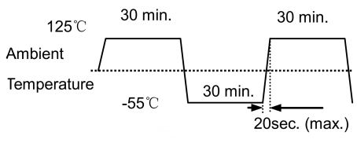
Resistance to  Low  Temperature | - No visible mechanical damage.  - R25 change: within ±2%.  - B Constant change: within ±1%. |  | - Temperature: -55±2℃  - Duration: 1000+24 hours.  - The chip shall be stabilized at normal condition for 1~2 hours before measuring.
Resistance  to High  Temperature | - No visible mechanical damage.  - R25 change: within ±1%.  - B Constant change: within ±1%. |  | - Temperature: 125±2℃  - Duration: 1000+24 hours.  - The chip shall be stabilized at normal condition for 1~2 hours before measuring.
Items | Requirements |  | Test Methods and Remarks
Damp Heat (Steady States) | - No visible mechanical damage.  - R25 change: within ±1%.  - B Constant change: within ±1% |  | - Temperature: 60±2℃  - Humidity: 90% to 95% RH.  - Duration: 1000+24 hours.  - The chip shall be stabilized at normal condition for 1~2 hours before measuring.
Loading at High Temperature (Life Test) | - No visible mechanical damage.  - R25 change: Within ±2%.  - B constant change: Within ±1%. |  | - Temperature: 85±2℃  - Duration: 1000+24 hours.  - Applied current: Max. Permissive Operating Current.  - The chip shall be stabilized at normal condition for 1~2 hours before measuring.

■ Packaging

No. | Name
① | Semiconductive Ceramics
② | Internal electrode
③ | Terminal electrode | Ag
④ | Terminal electrode | Ni
⑤ | Terminal electrode | Sn

- Figure
Cover (Top) tape
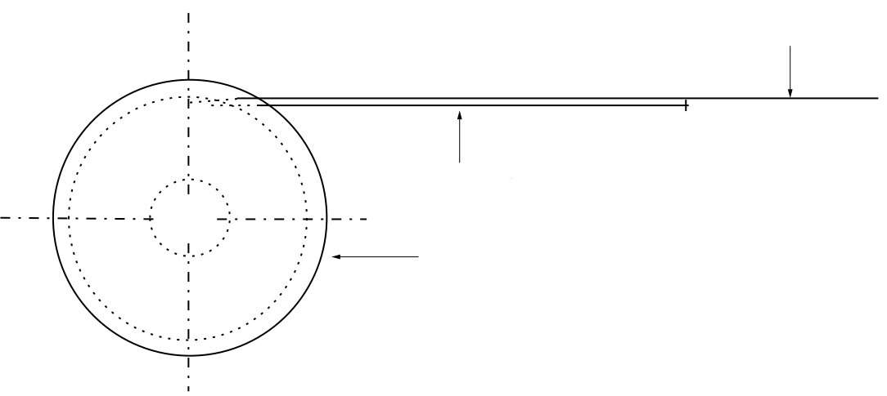

Carrier tape

Reel

400mm Min.
Leader
Blank portions 160mm Min.
Chip Cavity
Blank portions 100mm Min.
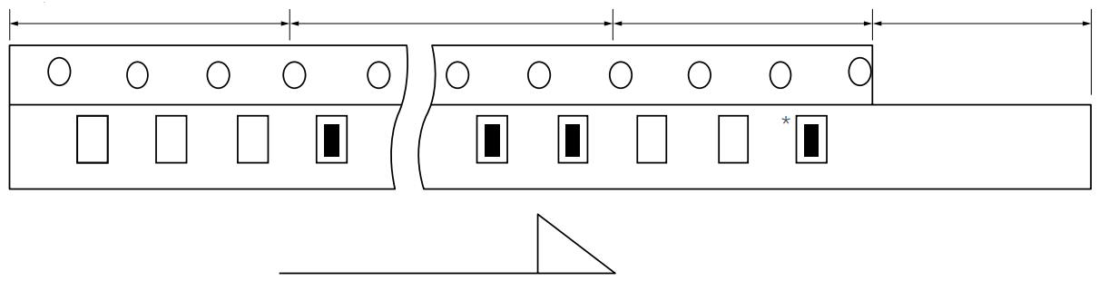

Unreeling

- Quantity
Size(EIA) |  | 0402 | 0603 | 0805 | 1206
Taping Type |  | PAPER | PAPER | PAPER | PLASTIC
Quantity | Reel | 10K | 4K | 4K | 3K
Quantity | Inner Box | 10K$×$10=100K | 4K$×$10=40K | 4K$×$10=40K | 3K$×$10=30K
Quantity | Outer Box | 10K$×$10$×$6=600K | 4K$×$10$×$6=240K | 4K$×$10$×$6=240K | 3K$×$10$×$6=180K

- Tape Size
- Cardboard(Paper) tape
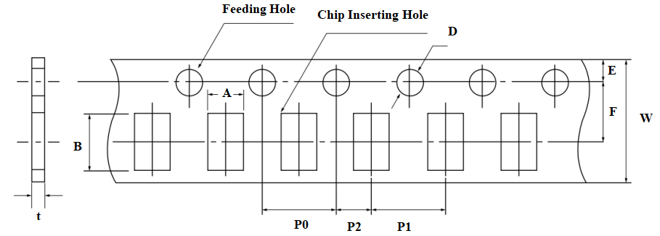

Size  (EIA) | A | B | W | F | E | P1 | P2 | P0 | D | t
0402 | 0.65±0.1 | 1.15±0.1 | 8.00  ±0.30 | 3.50  ±0.05 | 1.75  ±0.10 | 2.00  ±0.05 | 2.00  ±0.05 | 4.00  ±0.10 | φ1.50  +0.1/-0.03 | ≤0.8
0603 | 1.0±0.2 | 1.8±0.2 | 8.00  ±0.30 | 3.50  ±0.05 | 1.75  ±0.10 | 4.00  ±0.10 | 2.00  ±0.05 | 4.00  ±0.10 | φ1.50  +0.1/-0.03 | ≤1.1
0805 | 1.5±0.2 | 2.3±0.2 | 8.00  ±0.30 | 3.50  ±0.05 | 1.75  ±0.10 | 4.00  ±0.10 | 2.00  ±0.05 | 4.00  ±0.10 | φ1.50  +0.1/-0.03 | ≤1.1
Unit: mm

- Embossed (Plastic) tape

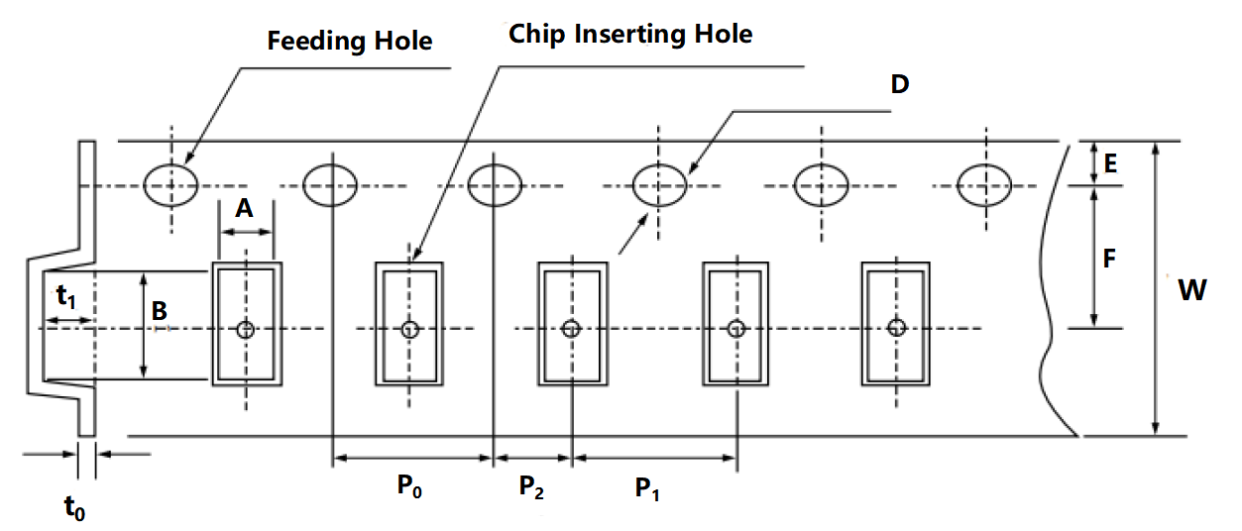

Size  (EIA) | A | B | W | F | E | P1 | P2 | P0 | D | t₀ | t₁
1206 | 1.88  ±0.10 | 3.50  ±0.10 | 8.00  ±0.30 | 3.50  ±0.05 | 1.75  ±0.10 | 4.00  ±0.10 | 2.00  ±0.05 | 4.00  ±0.10 | φ1.50  +0.1/-0.03 | ≤0.5 | ≤2.0

unit: mm
- Reel Size
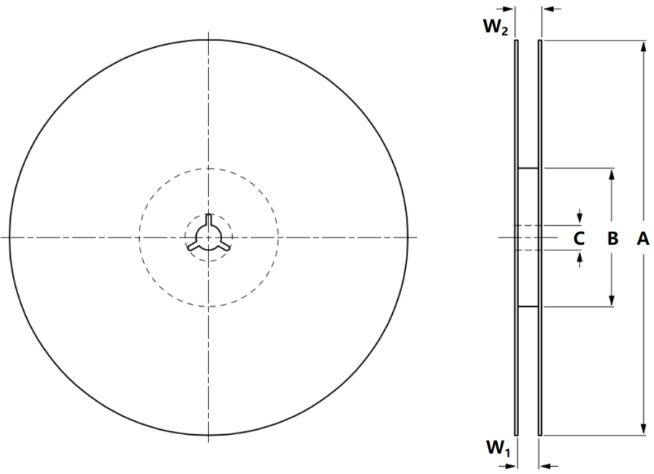
Type | Symbol | Dimensions(mm)
7”Reel | A | 178±2
7”Reel | B | 58±2
7”Reel | C | 13.5±0.2
7”Reel | W1 | 8.4+1.5/-0.0
7”Reel | W2 | ≤14.4

- BOX package
Double packaging with the paper type of inner box and outer box.
- Inner Box ：
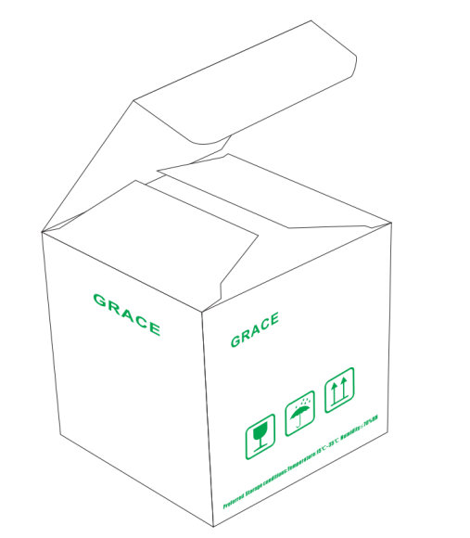

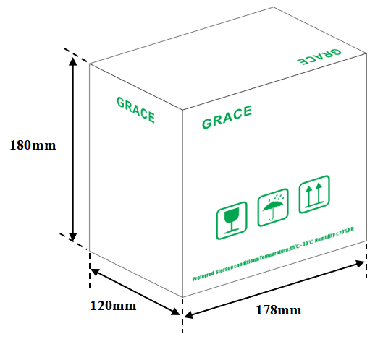

- Outer Box ：
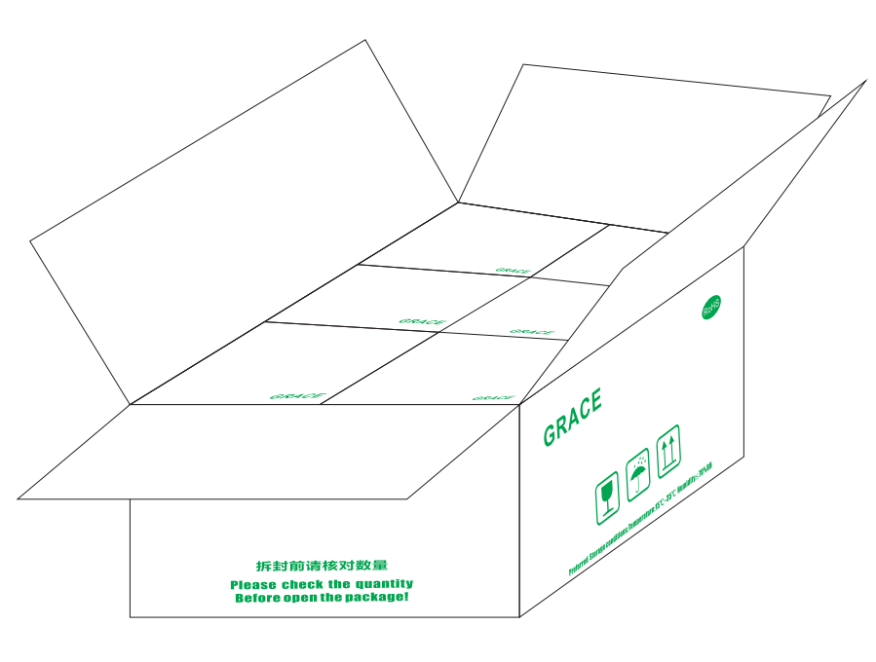
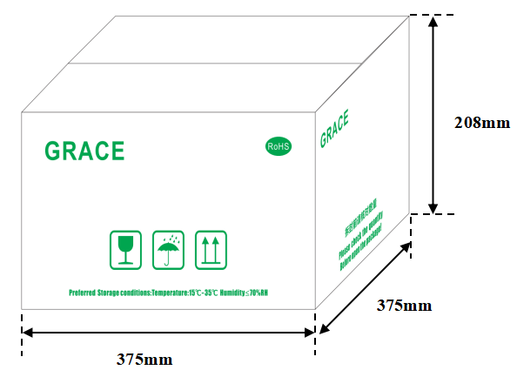

※ Box size specifications for reference.
■ Storage environment

No. | Name
① | Semiconductive Ceramics
② | Internal electrode
③ | Terminal electrode | Ag
④ | Terminal electrode | Ni
⑤ | Terminal electrode | Sn

- Recommendation for temperature/humidity
- Even taping and packaging materials are designed to endure a long-term storage, they should be stored with a temperature of -10~40℃and an RH of 0~70% otherwise, too high temperatures or humidity may deteriorate the quality of the chip rapidly.
- Packaging material may be deform-ed if package are stored where they are exposed to heat of direct sunlight.
- ‌As oxidization is accelerated when relative humidity is above 70%RH, the lower the humidity is, the better the solderability is.
- As the temperature difference may cause dew condensation during the storage of the chip, it is a must to maintain a temperature control environment.
- Shelf Life
- An allowable storage period should be within 12 months from the outgoing date of delivery in consideration of solderability.
- As for chips in storage over 12 months, please check solderability before use.
- Caution for corrosive environment
As corrosive gases may deteriorate the solderability of chip outer termination, it is a must to store chip in an environment without gases. chip that is exposed to corrosive gases may cause its quality issues due to the corrosion of plating layers and the penetration of moisture.
■ Process of Mounting and Soldering

No. | Name
① | Semiconductive Ceramics
② | Internal electrode
③ | Terminal electrode | Ag
④ | Terminal electrode | Ni
⑤ | Terminal electrode | Sn

- Mounting
- It is recommended to locate the major axis of chip in parallel to the direction in which the stress is applied.

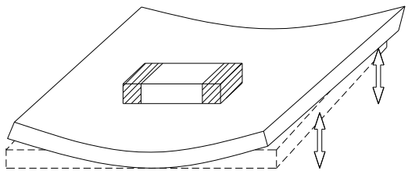
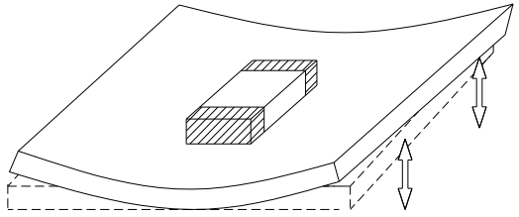

Not recommended Recommended
- Please take the following measures to effectively reduce the stress generated from the cutting of PCB. Select the mounting location shown below, since the mechanical stress is affected by a location and a direction of chip mounted near the cutting line.
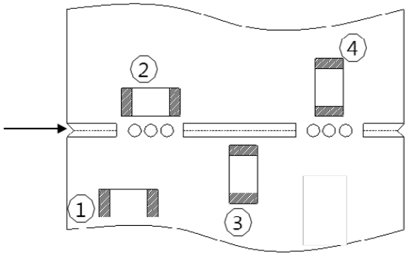

Worst ④ > ② = ③ >① Best
Cutting line

- If the chip is mounted near a screw hole, the board deflection may be occurred by screw torque. Mount the chip as far from the screw holes as possible.

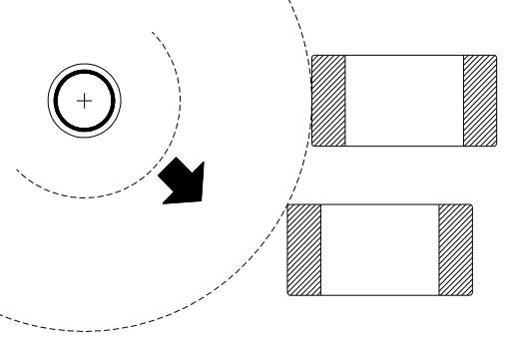
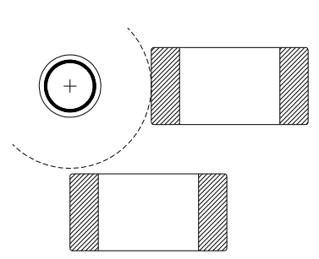

Not recommended Recommended

- Substrate fixes up back surface of substrate with support pin in impact of suction nozzle to wely deflection to the utmost, and substrate hold deflection, please. A representative example is shown in the following.
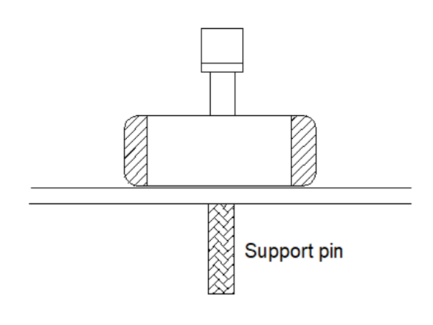
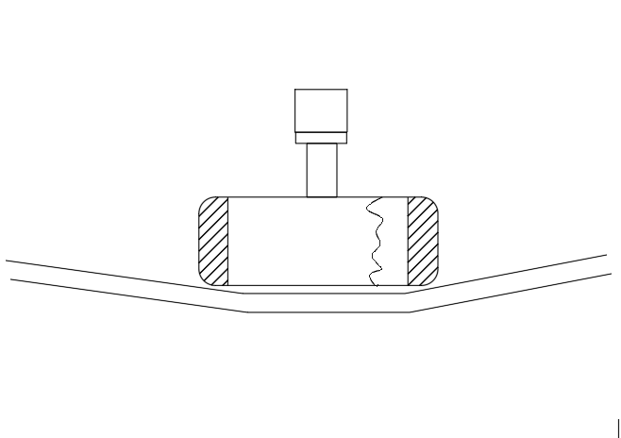
Force
Crack

Cases to avoid Recommended Case
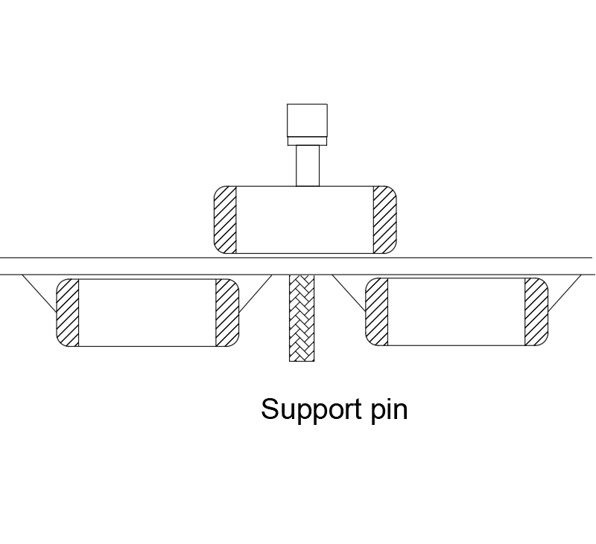
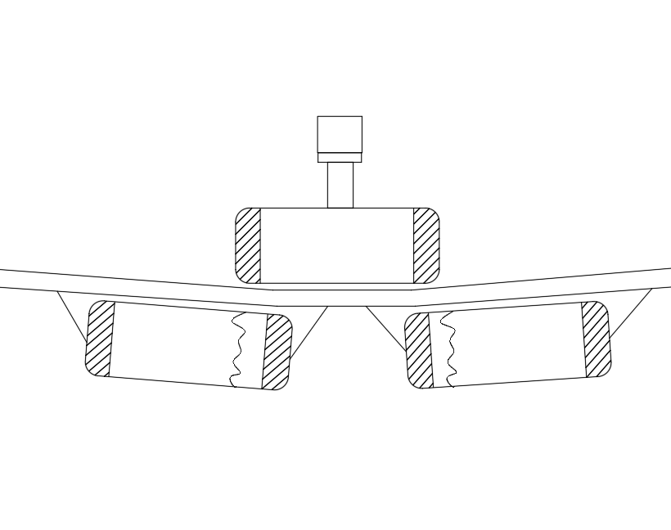
Crack

Cases to avoid Recommended Case
※ Dust accumulated in a suction nozzle and suction mechanism can impede a smooth movement of the nozzle. This may cause cracks in the chip due to the excessive force during mounting.If the mounting claw is worn out, it may cause cracks in the chip due to the uneven force during positioning.A regular inspection such as maintenance, monitor and replacement for the suction nozzle and mounting claw should be conducted.
- Reflow soldering
The reflow soldering temperature conditions are composed of temperature curves of Preheating, Temp. rise,
Heating, Peak and Gradual cooling. Large temperature difference inside the chip caused by rapid heat
application to the chip may lead to excessive thermal stresses, contributing to the thermal cracks. The
Preheating temperature requires controlling with great care so that tombstone phenomenon may be prevented.
Follow the recommended soldering conditions to avoid degradation of performance .

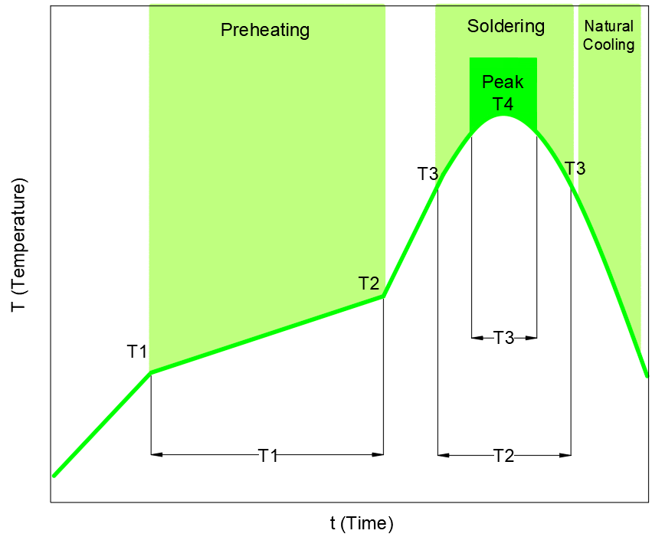

Item | Specification
Item | For eutectic mixture solder | For lead-free solder
Preheating temperature | 160 ～ 180 ℃ | 150 ～ 180 ℃
Solder melting temperature | 200 ℃ | 230 ℃
Maximum temperature | 240°C max． | 260 ℃ max.
Preheating time | 100s max. | 120s max.
Time to reach higher than the solder melting temperature | 30s max. | 40s max.
number of possible reflow cycles | 2 max. | 2 max.
※ Pre-heating is necessary for all constituents including the PCB to prevent the mechanical damages on the chip . The temperature difference between the PCB and the component surface must be kept to the minimum.
- Allowable temperature difference △T≦ 150 °C
- Use non-activated flux. (Max. Cl content less than 0.1%)

- Soldering Iron
Manual soldering can pose a great risk on creating thermal cracks in the chip. The high temperature soldering iron tip may come into a direct contact with the ceramic body of the chip due to the carelessness of an operator. Therefore, the soldering iron must be handled carefully, and close attention must be paid to the selection of the soldering iron tip and to temperature control of the tip.

Iron soldering power | Soldering time | Soldering Temp. | Number of times | Pre-heating
20W max. | 3s max. | 300±10℃ max. | Within each terminal  once(Within total of twice) | - ΔT≤130  - ≥60S

※ Keep the contact time between the outer termination of the chip and the soldering iron as short as possible. Long soldering time may cause problems such as adhesion deterioration by the leaching phenomenon of the outer termination.
- Control ΔT in the solder iron and preheating temperature;
- Caution - Iron tip should not contact with ceramic body directly;
- ‌Do not cool down the chip and PCB rapidly after soldering;
- Lead-free solder: Sn-3.0Ag-0.5CU.
- Spot heater
Compared to local heating with a soldering iron, hot air heating by a spot heater heats the overall component and board, therefore, it tends to lessen the thermal shock. In the case of a high density mounted board, a spot heater can also prevent concerns of the soldering iron making direct contact with the component.
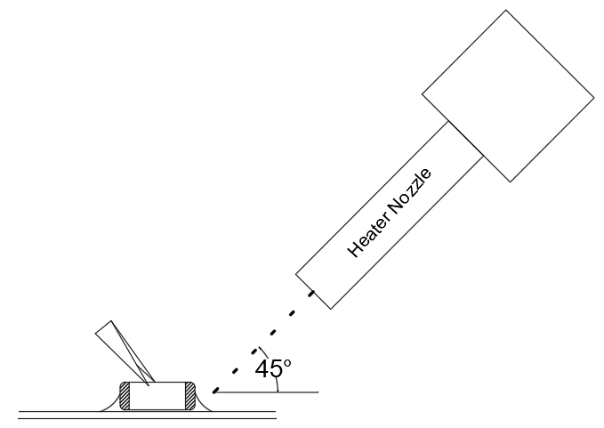

Distance | Hot Air Application angle | Hot Air Temperature Nozzle Outlet | Application Time
≥ 5mm | 45℃ | ≤ 400℃ | ≤ 10s
※ If the distance from the air nozzle outlet to the chip is too close, the chip may be cracked due to the thermal stress.
- Recommended Amount of Solder
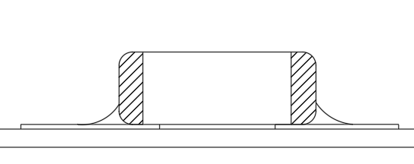
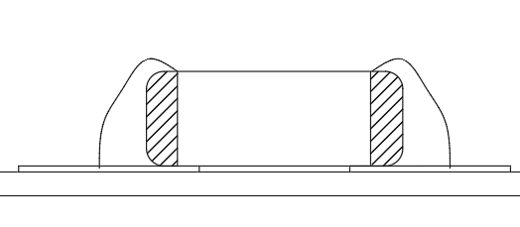

Excessive amount Insufficient amount
※ Notes:
- Too much solder amount will increase the risk of PCB bending or cause other damages.
- Too little solder amount will result in the chip breaking loose from the PCB due to the inadequate
adhesive strength.
- Check if the solder has been applied properly and ensure the solder fillet has a proper shape.
- Cleaning
- ‌In general, cleaning is unnecessary if rosin flux is used.
When acidic flux is used strongly, chlorine in the flux may dissolve into some types of cleaning fluids, thereby affecting the performance of the chip.
This means that the cleansing solution must be carefully selected and should always be new.
- Cautions for cleaning
The chip or solder joint may be cracked with the vibration of PCB, if ultrasonic vibration is too strong during cleaning. Therefore，test should be done for the cleaning equipment and its process before the cleaning in order to avoid damages on the chip，you can refer to the following conditions for cleaning.
Ultrasound output | Ultrasound frequency | Cleaning time
20W/liter or less | 40kHz or less | 5minutes or less


Limitation

No. | Name
① | Semiconductive Ceramics
② | Internal electrode
③ | Terminal electrode | Ag
④ | Terminal electrode | Ni
⑤ | Terminal electrode | Sn

Please contact us with usage environment information such as voltage, current, temperature, or other special conditions before using our products for the applications listed below. The products are not designed or warranted to meet the requirements of the applications listed below, whose performance and/or quality require especially high reliability, or whose failure, malfunction or trouble might directly cause damage to society, person, or property. Please understand that we are not responsible for any damage or liability caused by use of the products in any of the applications below.
If you have any questions regarding this 'Limitation'，you should first contact our sales personnel or application engineers.
- Aerospace/Aviation equipment1wheeler, 2wheeler and 3wheeler vehicle
- Automotive of Transportation equipment
- Military equipment
- Atomic energy-related equipment
- Undersea equipment
- Medical equipment
- Disaster prevention/crime prevention equipment
- Power plant control equipment
- Traffic signal equipment
- Data-processing equipment
- Electric heating apparatus，burning equipment
- Safety equipment
- Any other applications with the same as or similar complexity or reliability to the applications

